Chapter 2

Exercise Solutions

Ex. 2.1
- 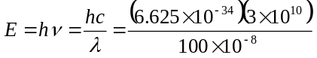
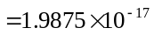J
or 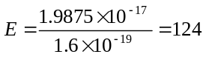eV
- 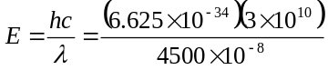
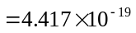J
or 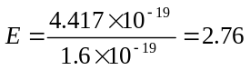eV
_______________________________________

Ex 2.2
(a) 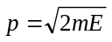
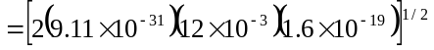
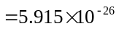kg-m/s
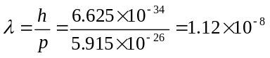m
or 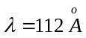
- 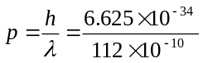
kg-m/s
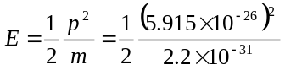
=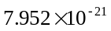J
or 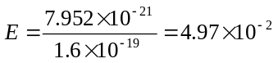eV
_______________________________________

Ex 2.3
- 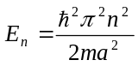
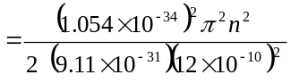
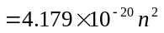 J
or 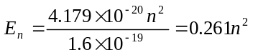eV
Then
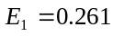eV, 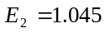eV, 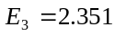eV
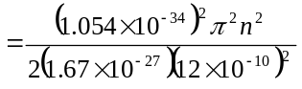
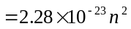 J
or 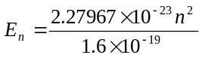
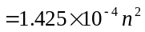eV
Then 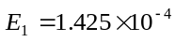eV
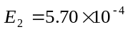eV
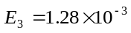eV
_______________________________________

Ex 2.4
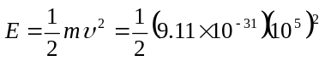
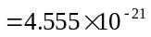J
Now
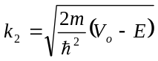 Set 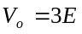
Then
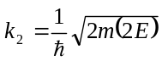
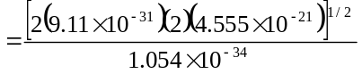
or
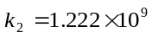m
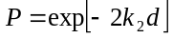
- 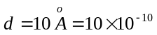m
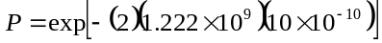
or
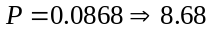%
- 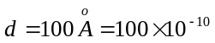m
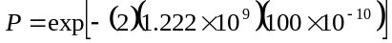
or
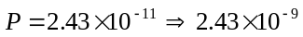%

_______________________________________

Ex 2.5
- 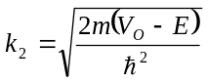
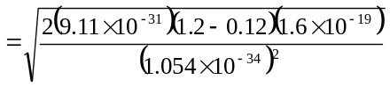
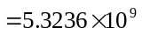 m
Then
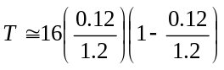
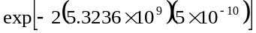
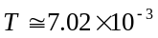
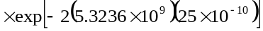
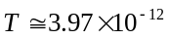
_______________________________________

Ex 2.6
From Example 2.6, we have
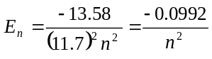eV
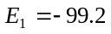meV, 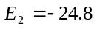meV,
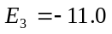meV
_______________________________________

Test Your Understanding

TYU 2.1
- 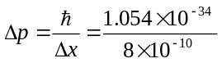
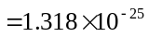kg-m/s
- 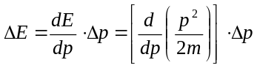
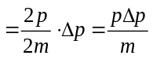
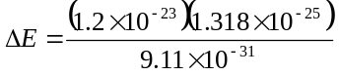
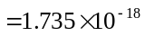 J or 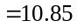eV
_______________________________________

TYU 2.2
- 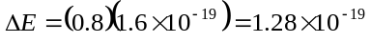eV
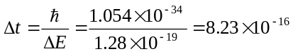s
- Same as part (a), 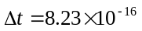s
_______________________________________

TYU 2.3
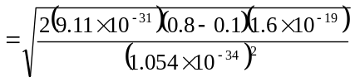
=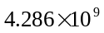m
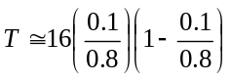
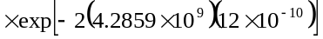
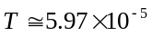
- 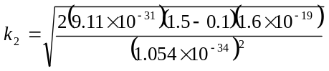
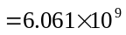m
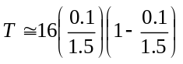
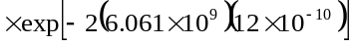
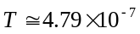
_______________________________________

TYU 2.4
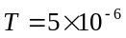
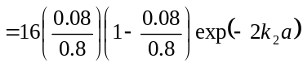
so that 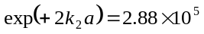
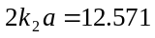
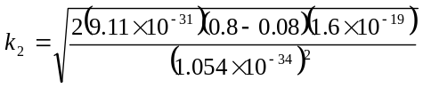
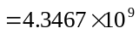m
Then
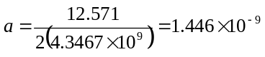m
or 


